**Lab Report. 01**

**Title: Lab Report**

*Course title: Computer Graphics Lab*

*Course code: CSE-304*

*3rd Year 1st Semester 2022*

**Date of Submission**: 28/05/2023



***Submitted to-***

*Dr. Mohammad Shorif Uddin*

*Professor*

*Department of Computer Science and Engineering*

*Jahangirnagar University*

*Savar, Dhaka-1342*

*And*

*Dr. Morium Akter*

*Associate Professor*

*Department of Computer Science and Engineering*

*Jahangirnagar University*

*Savar, Dhaka-1342*

| **Sl** | Class Roll | Exam Roll | Name |
| --- | --- | --- | --- |
| 01 | 390 |  | Md Abdullah Al Mamun |

Department of Computer Science and Engineering

Jahangirnagar University

Savar, Dhaka, Bangladesh

Scan conversion of a point:

Source code:

| #include<bits/stdc++.h>  using namespace std;  int main()  {  float x,y;  cout << "Enter point(x,y)" << endl;  cin >> x>>y;  int ax,by;  ax = floor(x);  by = floor(y);  cout << "Scanned points are  ("<<ax<<","<<by<<")"<<endl;  } |
| --- |

Output:

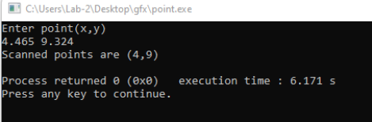

Department of Computer Science and Engineering

Jahangirnagar University

Savar, Dhaka, Bangladesh

Page **2** of **6**

Scan converting a line using DDA algorithm:

Source code:

| #include<bits/stdc++.h>  #include<graphics.h>  using namespace std;  void drawlinedda(int x1, int y1, int x2, int y2)  {  int dx = x2 - x1;  int dy = y2 - y1;  int steps = abs(dx) > abs(dy) ? abs(dx) : abs(dy);  float xincrement =  static_cast<float>(dx) / steps; float yincrement =  static_cast<float>(dy) / steps; float x = x1;  float y = y1;  for(int i=0; i<=steps; i++) {    putpixel(static_cast<int>(x),static _cast<int>(y),WHITE);  x += xincrement;  y += yincrement;  }  } | int main()  {  int gd = DETECT, gm;  initgraph(&gd,&gm, "");  int x1,y1,x2,y2;  cout << "Enter first coordinate (x1,y1):" << endl;  cin >> x1 >> y1;  cout << "Enter first coordinate (x2,y2):" << endl;  cin >> x2>>y2;  drawlinedda(x1,y1,x2,y2); delay(50000000);  closegraph();  return 0;  } |
| --- | --- |

Output:

Department of Computer Science and Engineering

Jahangirnagar University

Savar, Dhaka, Bangladesh

Page **3** of **6**

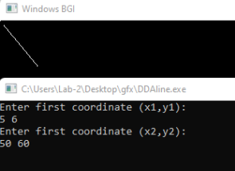

Scan Converting a line using Brasenham Algorithm

Source code:

| #include<bits/stdc++.h>  #include<graphics.h>  using namespace std;  void drawlinebresenham(int x1, int y1, int x2, int y2)  {  int dx = abs(x2 - x1);  int dy = abs(y2- y1);  int sx = (x1 < x2)? 1 : -1; int sy = (y1 < y2)? 1 : -1; int err = dx - dy;  while(true)  {  putpixel(x1,y1,WHITE); if(x1==x2 && y1==y2) break;  int dt = 2*err;  if(dt>-dy)  {  err -= dy;  x1 += sx;  } | if(dt < dx)  {  err += dx;  y1 += sy;  }  }  }  int main()  {  int gd = DETECT, gm;  initgraph(&gd,&gm, ""); int x1,y1,x2,y2;  cout << "Enter first  coordinate (x1,y1):" << endl; cin >> x1 >> y1;  cout << "Enter first  coordinate (x2,y2):" << endl; cin >> x2>>y2;    drawlinebresenham(x1,y1,x2,y2); delay(50000000);  closegraph();  return 0;  } |
| --- | --- |

Department of Computer Science and Engineering

Jahangirnagar University

Savar, Dhaka, Bangladesh

Page **4** of **6**

Output:

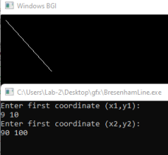Scan converting a circle using Brasenham circle algorithm: Source code:

Department of Computer Science and Engineering

Jahangirnagar University

Savar, Dhaka, Bangladesh

Page **5** of **6**

| #include <iostream>  #include <cmath>  #include <graphics.h>  using namespace std;  void drawCircleBresenham(int xc, int yc, int radius)  {  int x = 0;  int y = radius;  int d = 3 - 2 * radius;  while (x <= y)  {  putpixel(xc + x, yc + y, WHITE);  putpixel(xc - x, yc + y, WHITE);  putpixel(xc + x, yc - y, WHITE);  putpixel(xc - x, yc - y, WHITE);  putpixel(xc + y, yc + x, WHITE);  putpixel(xc - y, yc + x, WHITE);  putpixel(xc + y, yc - x, WHITE);  putpixel(xc - y, yc - x, WHITE);  if (d < 0)  {  d += 4 * x + 6; } | else  {  d += 4 * (x - y) + 10;  y--;  }  x++;  }  }int main()  {  int gd = DETECT, gm;  initgraph(&gd, &gm, "");  int xc, yc, radius;  cout << "Enter the  coordinates of the center (xc, yc): ";  cin >> xc >> yc;  cout << "Enter the radius of the circle: ";  cin >> radius;  drawCircleBresenham(xc, yc, radius);  delay(5000);  closegraph();  return 0;  } |
| --- | --- |

Output:

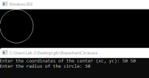

Department of Computer Science and Engineering

Jahangirnagar University

Savar, Dhaka, Bangladesh

Page **6** of **6**